# Convert smiles in excel to separate smiles files (Windows only)

1. Create a working directory and name it anything you like.
2. If you have not done so, navigate to this [link](https://github.com/emeli-frank/informatics) with a PC, click the green button that says “Clone or download” to download the zip file that contains what you need.



1. Unzip the contents of the downloaded file and navigate to informatics-master >> windows >> xlsx_to_smiles >> smiles.exe
2. Place it in your working directory.
3. With a recent version of excel, create a sheet containing 2 columns without a header
   * The first column is the name of the smiles file. E.g. MMV010764
   * The second column is the smiles string. E.g. C(Nc1nn2c(cnc2s1)c3cccs3)C4CCOCC4

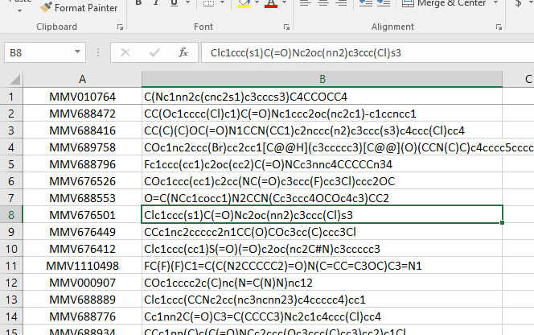

1. Save this file with the name “smiles” in your working directory. (Now you have 2 files in your working directory: the downloaded program (smiles.exe) and your excel sheet (smiles.xlsx)

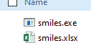

1. Double click the downloaded program (smiles.exe) and hit enter to proceed. After it completes, your working directory should look like this. A new smiles folder is created for you. Your generated smiles files are in this folder

